As the white box testing suggests here we create test cases keeping in mind the codes of the software and hence we created test cases and proceeded.

Tools:

Karma + Jasmine + VS Code

Jasmine is a behavior-driven development framework for testing JavaScript code. It does not depend on any other JavaScript frameworks. It does not require a DOM. And it has a clean, obvious syntax so that you can easily write tests.

Karma is a tool that enables the running of source code (i.e. JavaScript) against real browsers via the CLI. The fact that it runs against real browsers rather than “fakes” with a virtual DOM is extremely powerful. DOM implementations vary across browsers therefore the idea is to use the actual browsers for correctness.

Also PHPunit was used.

Screenshot of one test case is discussed:

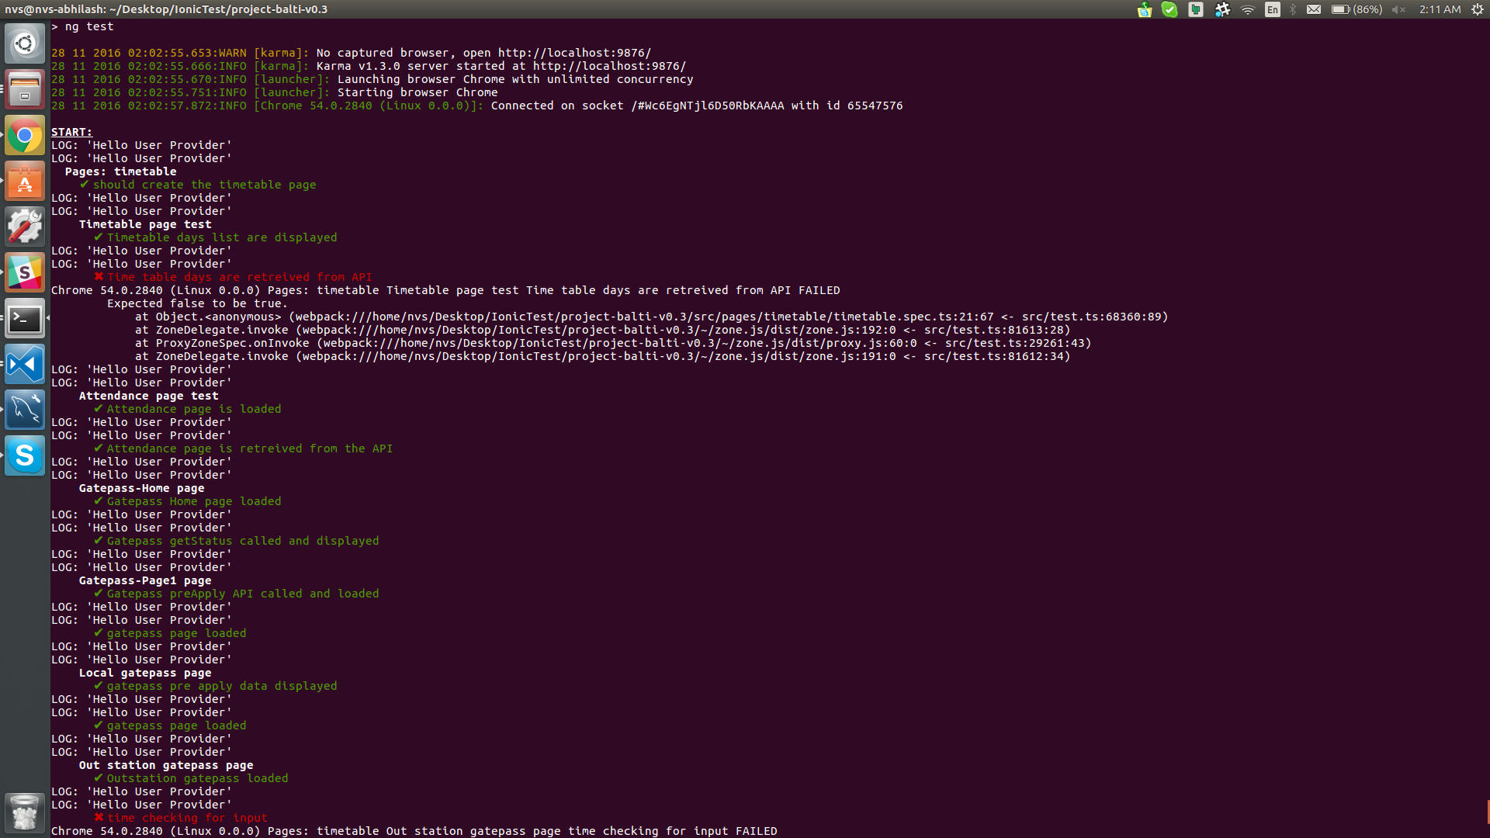

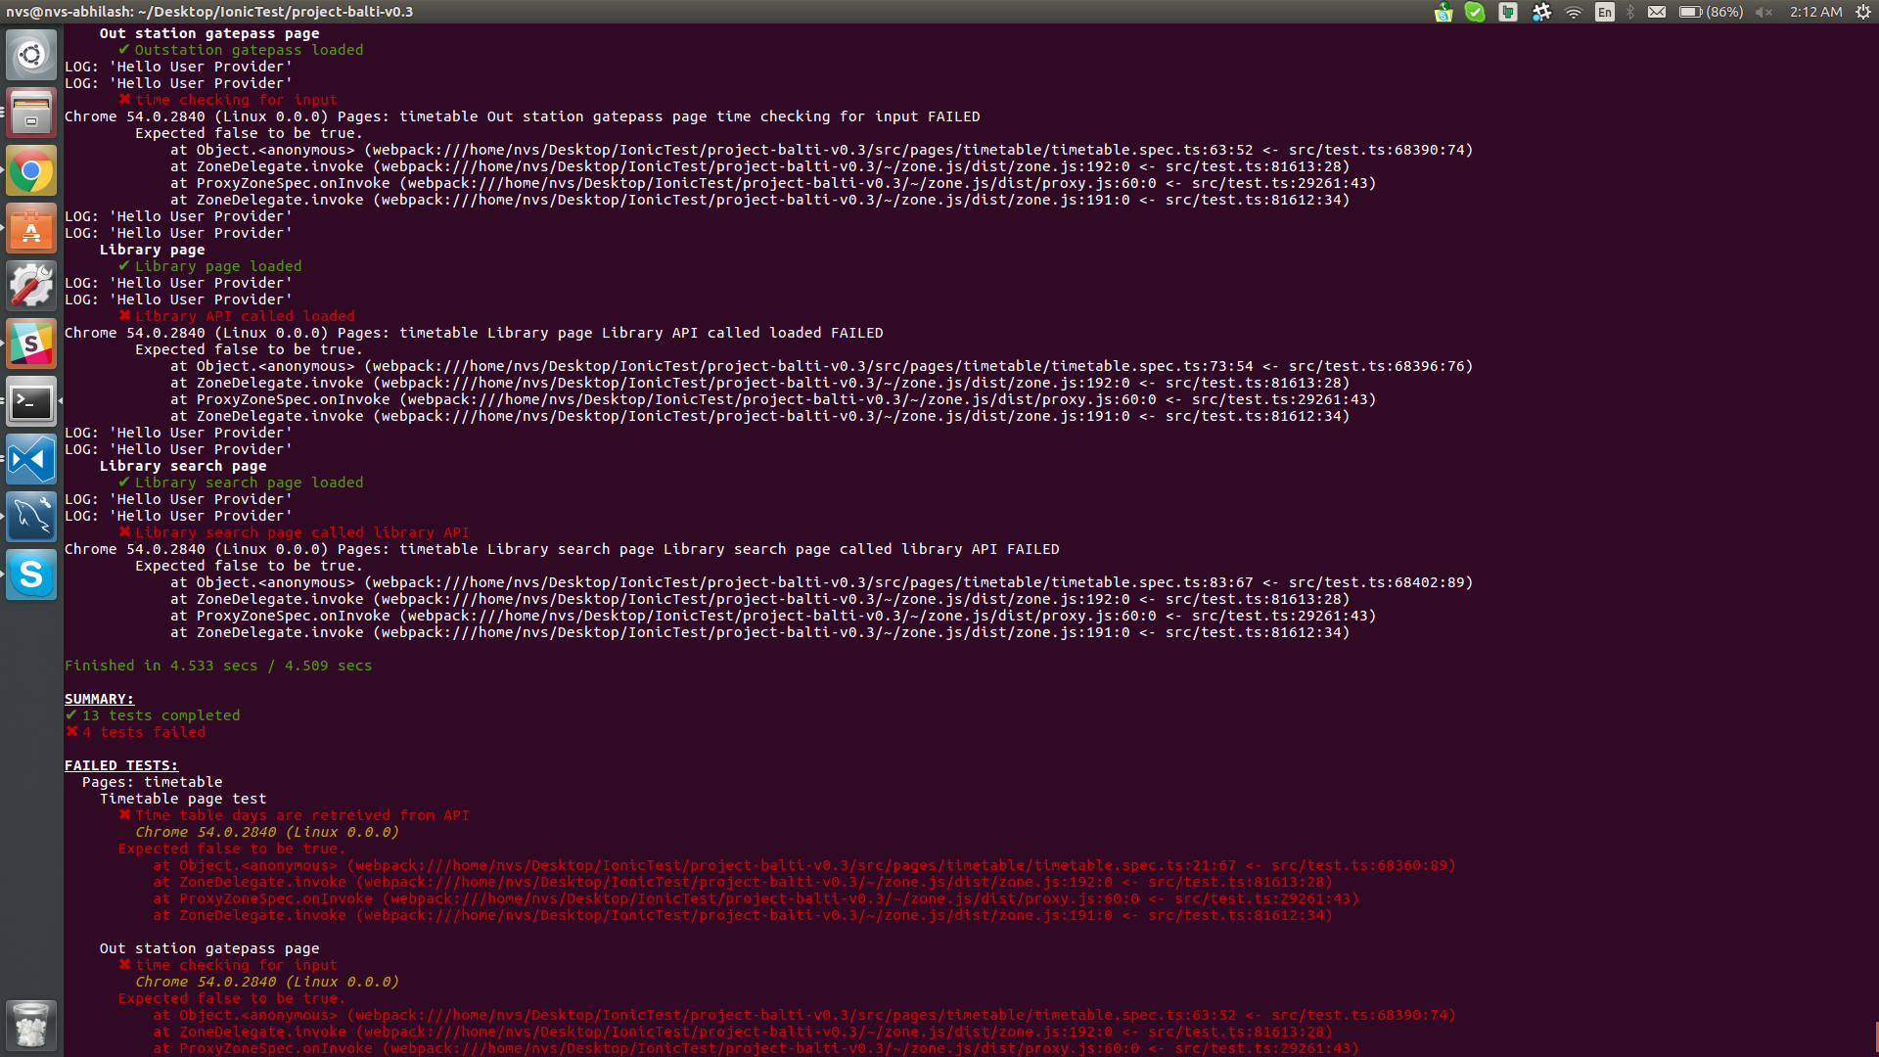

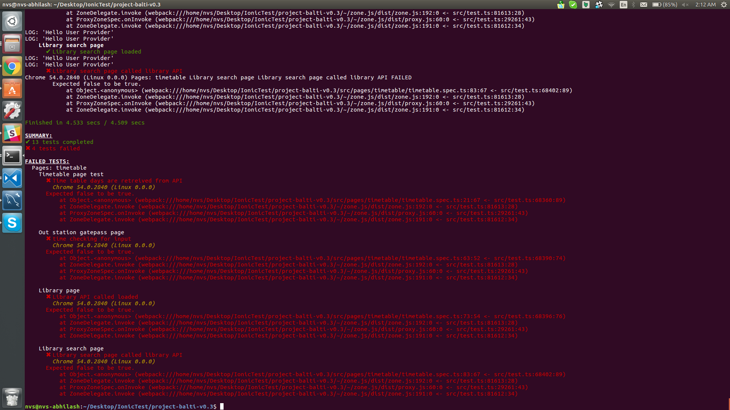

Below is the result of every test cases:

|  |  |
| --- | --- |
| **Testcase Name** | **Testcase Result** |
| Timetable Page | Successfully passed |
| Timetable Page Test | Sucessfully Passed |
| Attendance Page Test | Sucessfully Passed |
| Gatepass Home Page | Sucessfully Passed |
| Gatepass page-1 page | Sucessfully Passed |
| Local gatepass page | Sucessfully Passed |
| Outstation Gatepass | Failed |
| Library page | Failed |
| Library search page | Failed |